Name : Dharanidharan Ramasamy Karuppanasamy

SUID : 320028178

**Sigmoid function accuracy:**

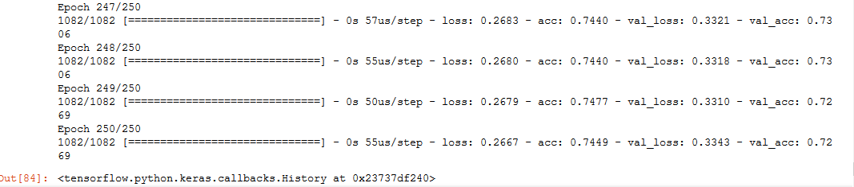

**Linear Piecewise:**

1. Accuracy when number of linear segments is 4 = 0.6664 (n=4):

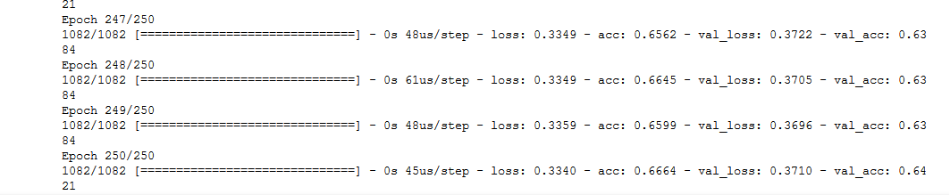

1. Accuracy when number of linear segments is 6 = 0.685 (n=6):

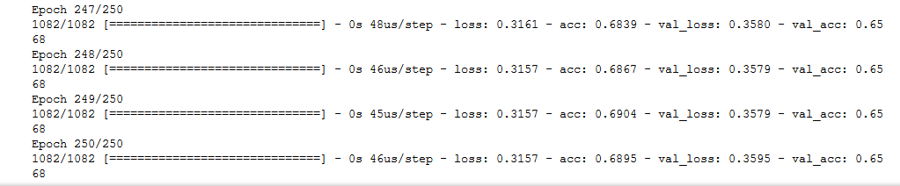

1. Accuracy when number of linear segments is 8 = 0.6987 (n=8):

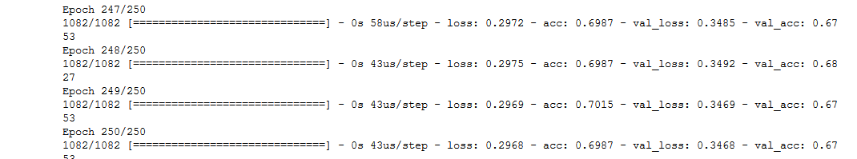

1. Accuracy when number of linear segments is 10 = 0.7366 (n=10):

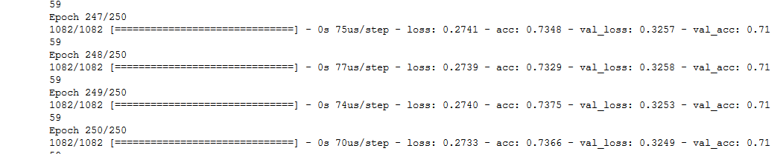

1. Accuracy when number of linear segments is 10 = 0.7237 (n=12):

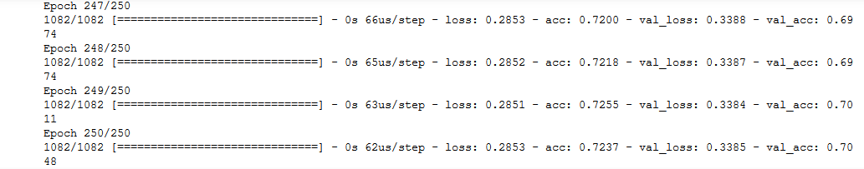

1. Accuracy when number of linear segments is 16 = 0.7569 (n=16)

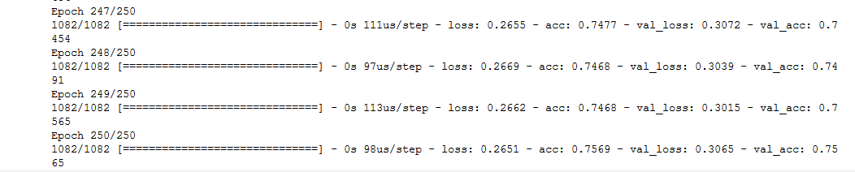

1. The table and the graph depict the best accuracy obtained after 250 iterations of each class

|  |  |  |
| --- | --- | --- |
| **Segments** | **Linear Piecewise** | **Sigmoid** |
| n=4 | 0.6664 | 0.745 |
| n=6 | 0.6895 |
| n=8 | 0.6987 |
| n=10 | 0.7366 |
| n=12 | 0.7237 |
| n=16 | 0.7569 |

So as the number of linear segments increase the accuracy rate also gets improved. Moreover, the result of applying sigmoid function is lower than 16 segment linear piecewise function accuracy. Hence a complex computation (sigmoid) can be replaced effectively by linear piecewise segments.

1. Computational effort required to get satisfactory results (e.g., MSE=0.01)

It takes about 10000 computations to make the MSE value to 0.11 using sigmoid function

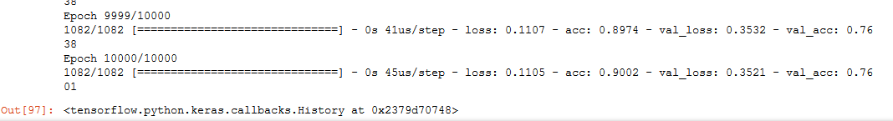

So, to get a MSE of 0.01 it would take around 100000 computations in sigmoid function

For linear piecewise function with 4 segments 15000 computations has an MSE of 0.3321. To reduce this to 0.01 it would take around 1500000 computations.

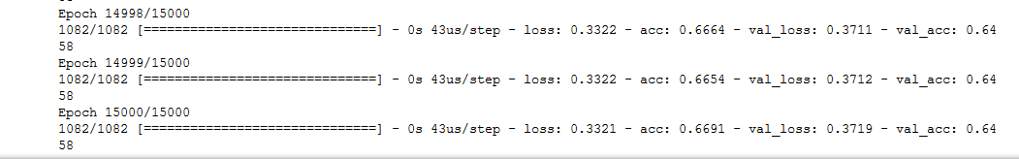

But as the number of linear segments increases the accuracy gets improved which means the number of computations required to get MSE of 0,01 will reduce when the number of linear segments gets increased.

|  |  |
| --- | --- |
| Techniques | Computational effort to make MSE 0.01 |
| n=4 | Very Very High |
| n=6 | Very Very High |
| n=8 | Very High |
| n=10 | High |
| n=12 | High/Medium |
| n=16 | Medium |
| Sigmoid | Medium |